Measurement
# Source: AI Source: Provided by: [Data Path: Persons Table -> ID Column: 1, Name_En Column: Motasem Essam] -> From: [ChatGPT] on [7/17/2026]
Measurement is the process of determining the size, amount, quantity, capacity, or extent of a physical property by comparing it with an agreed-upon standard unit. It allows observations to be expressed numerically, making them accurate, consistent, and comparable.
Measurement is one of the fundamental concepts in mathematics, science, engineering, technology, medicine, economics, and everyday life.

Definition
# Source: AI Source: Provided by: [Data Path: Persons Table -> ID Column: 1, Name_En Column: Motasem Essam] -> From: [ChatGPT] on [7/17/2026]
Measurement is the process of assigning a numerical value to a physical quantity by comparing it with a standard unit of measurement.
It is generally expressed as:
$$\boxed{\text{Measurement}=\text{Numerical Value}×\text{Unit}}$$
Example:
- $5\text{ m}$
- $72\text{ kg}$
- $3.5\text{ L}$

Purpose of Measurement
# Source: AI Source: Provided by: [Data Path: Persons Table -> ID Column: 1, Name_En Column: Motasem Essam] -> From: [ChatGPT] on [7/17/2026]
Measurement is used to:
- Quantify physical properties.
- Compare objects or quantities.
- Ensure accuracy and precision.
- Standardize observations.
- Support scientific experiments.
- Perform engineering calculations.
- Facilitate trade and commerce.
- Solve mathematical problems.

Components of a Measurement
# Source: AI Source: Provided by: [Data Path: Persons Table -> ID Column: 1, Name_En Column: Motasem Essam] -> From: [ChatGPT] on [7/17/2026]
Every measurement consists of two parts:
- Numerical Value (Magnitude)
- Unit of Measurement
Example:
$$15\text{ cm}$$
- Numerical value = 15
- Unit = centimeter (cm)

Physical Quantities That Can Be Measured
# Source: AI Source: Provided by: [Data Path: Persons Table -> ID Column: 1, Name_En Column: Motasem Essam] -> From: [ChatGPT] on [7/17/2026]
Measurement applies to many physical quantities, including:
- Length
- Distance
- Height
- Width
- Depth
- Area
- Perimeter
- Volume
- Capacity
- Mass
- Weight
- Time
- Temperature
- Speed
- Velocity
- Acceleration
- Force
- Pressure
- Energy
- Power
- Electric current
- Voltage
- Resistance
- Frequency
- Angle

Types of Measurement

Length
# Source: AI Source: Provided by: [Data Path: Persons Table -> ID Column: 1, Name_En Column: Motasem Essam] -> From: [ChatGPT] on [7/17/2026]
Measures distance between two points.
Common units:
- millimeter (mm)
- centimeter (cm)
- meter (m)
- kilometer (km)

Mass
# Source: AI Source: Provided by: [Data Path: Persons Table -> ID Column: 1, Name_En Column: Motasem Essam] -> From: [ChatGPT] on [7/17/2026]
Measures the amount of matter.
Common units:
- milligram (mg)
- gram (g)
- kilogram (kg)
- tonne (t)

Time
# Source: AI Source: Provided by: [Data Path: Persons Table -> ID Column: 1, Name_En Column: Motasem Essam] -> From: [ChatGPT] on [7/17/2026]
Measures duration.
Common units:
- second (s)
- minute (min)
- hour (h)
- day
- year

Temperature
# Source: AI Source: Provided by: [Data Path: Persons Table -> ID Column: 1, Name_En Column: Motasem Essam] -> From: [ChatGPT] on [7/17/2026]
Measures the degree of hotness or coldness.
Common units:
- Celsius (°C)
- Fahrenheit (°F)
- Kelvin (K)

Area
# Source: AI Source: Provided by: [Data Path: Persons Table -> ID Column: 1, Name_En Column: Motasem Essam] -> From: [ChatGPT] on [7/17/2026]
Measures the size of a surface.
Common units:
- mm²
- cm²
- m²
- km²

Volume
# Source: AI Source: Provided by: [Data Path: Persons Table -> ID Column: 1, Name_En Column: Motasem Essam] -> From: [ChatGPT] on [7/17/2026]
Measures the space occupied by an object.
Common units:
- cm³
- m³
- L
- mL

Capacity
# Source: AI Source: Provided by: [Data Path: Persons Table -> ID Column: 1, Name_En Column: Motasem Essam] -> From: [ChatGPT] on [7/17/2026]
Measures how much a container can hold.
Common units:
- milliliter (mL)
- liter (L)

Angle
# Source: AI Source: Provided by: [Data Path: Persons Table -> ID Column: 1, Name_En Column: Motasem Essam] -> From: [ChatGPT] on [7/17/2026]
Measures rotation.
Common units:
- degree (°)
- radian (rad)

Systems of Measurement
# Source: AI Source: Provided by: [Data Path: Persons Table -> ID Column: 1, Name_En Column: Motasem Essam] -> From: [ChatGPT] on [7/17/2026]
The most common measurement systems are:
International System of Units (SI)
The modern worldwide standard.
Examples:
- meter
- kilogram
- second
- ampere
- kelvin
- mole
- candela

Metric System
# Source: AI Source: Provided by: [Data Path: Persons Table -> ID Column: 1, Name_En Column: Motasem Essam] -> From: [ChatGPT] on [7/17/2026]
A decimal-based measurement system using powers of ten.
Examples:
- mm
- cm
- m
- km

Imperial System
# Source: AI Source: Provided by: [Data Path: Persons Table -> ID Column: 1, Name_En Column: Motasem Essam] -> From: [ChatGPT] on [7/17/2026]
Used mainly in the United States and a few other countries.
Examples:
- inch
- foot
- yard
- mile
- pound
- gallon

SI Base Quantities
# Source: AI Source: Provided by: [Data Path: Persons Table -> ID Column: 1, Name_En Column: Motasem Essam] -> From: [ChatGPT] on [7/17/2026]
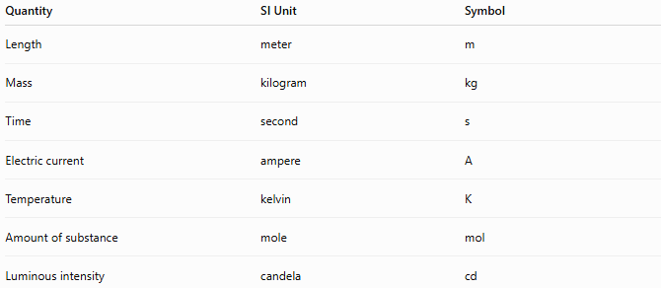
Quantity | SI Unit | Symbol
Length | meter | m
Mass | kilogram | kg
Time | second | s
Electric current | ampere | A
Temperature | kelvin | K
Amount of substance | mole | mol
Luminous intensity | candela | cd

Derived Measurements
# Source: AI Source: Provided by: [Data Path: Persons Table -> ID Column: 1, Name_En Column: Motasem Essam] -> From: [ChatGPT] on [7/17/2026]
Some measurements are obtained from combinations of base quantities.
Examples:
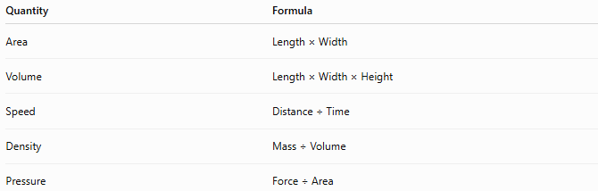
Quantity | Formula
Area | Length × Width
Volume | Length × Width × Height
Speed | Distance ÷ Time
Density | Mass ÷ Volume
Pressure | Force ÷ Area

Measuring Instruments
# Source: AI Source: Provided by: [Data Path: Persons Table -> ID Column: 1, Name_En Column: Motasem Essam] -> From: [ChatGPT] on [7/17/2026]
Common measuring instruments include:
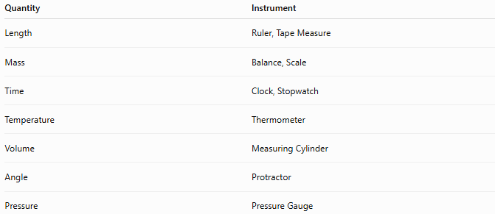
Quantity | Instrument
Length | Ruler, Tape Measure
Mass | Balance, Scale
Time | Clock, Stopwatch
Temperature | Thermometer
Volume | Measuring Cylinder
Angle | Protractor
Pressure | Pressure Gauge

Characteristics of Good Measurement
# Source: AI Source: Provided by: [Data Path: Persons Table -> ID Column: 1, Name_En Column: Motasem Essam] -> From: [ChatGPT] on [7/17/2026]
A good measurement should be:
- Accurate
- Precise
- Repeatable
- Consistent
- Reliable
- Standardized

Importance of Measurement
# Source: AI Source: Provided by: [Data Path: Persons Table -> ID Column: 1, Name_En Column: Motasem Essam] -> From: [ChatGPT] on [7/17/2026]
Measurement is essential in:
- Mathematics
- Science
- Physics
- Chemistry
- Biology
- Engineering
- Construction
- Medicine
- Manufacturing
- Commerce
- Navigation
- Astronomy

Everyday Examples
# Source: AI Source: Provided by: [Data Path: Persons Table -> ID Column: 1, Name_En Column: Motasem Essam] -> From: [ChatGPT] on [7/17/2026]
Measurement is used when:
- Measuring a person's height.
- Weighing food.
- Timing a race.
- Measuring room dimensions.
- Checking body temperature.
- Calculating travel distance.
- Filling a fuel tank.
- Buying fabric.

Common Mistakes
# Source: AI Source: Provided by: [Data Path: Persons Table -> ID Column: 1, Name_En Column: Motasem Essam] -> From: [ChatGPT] on [7/17/2026]
- Omitting the unit.
- Mixing measurement systems.
- Confusing mass and weight.
- Using the wrong measuring instrument.
- Ignoring measurement precision.

Key Points
# Source: AI Source: Provided by: [Data Path: Persons Table -> ID Column: 1, Name_En Column: Motasem Essam] -> From: [ChatGPT] on [7/17/2026]
- Measurement compares a quantity with a standard unit.
- Every measurement consists of a numerical value and a unit.
- SI units are the international standard.
- Measurements are used throughout mathematics, science, engineering, and everyday life.
- Accurate and standardized measurements enable reliable communication and calculation.

Measurement vs. Estimation
# Source: AI Source: Provided by: [Data Path: Persons Table -> ID Column: 1, Name_En Column: Motasem Essam] -> From: [ChatGPT] on [7/17/2026]
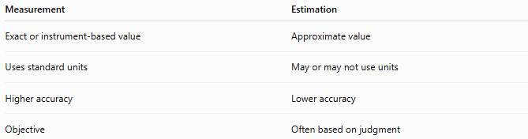
Measurement | Estimation
Exact or instrument-based value | Approximate value
Uses standard units | May or may not use units
Higher accuracy | Lower accuracy
Objective | Often based on judgment

Measurement vs. Counting
# Source: AI Source: Provided by: [Data Path: Persons Table -> ID Column: 1, Name_En Column: Motasem Essam] -> From: [ChatGPT] on [7/17/2026]
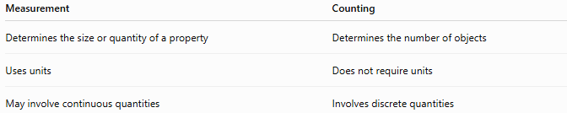
Measurement | Counting
Determines the size or quantity of a property | Determines the number of objects
Uses units | Does not require units
May involve continuous quantities | Involves discrete quantities

Conclusion
# Source: AI Source: Provided by: [Data Path: Persons Table -> ID Column: 1, Name_En Column: Motasem Essam] -> From: [ChatGPT] on [7/17/2026]
Measurement is the process of determining the magnitude of a physical quantity by comparing it with a standard unit. Every measurement consists of a numerical value and a unit of measurement, allowing quantities to be expressed accurately and consistently. Measurement forms the foundation of mathematics, science, engineering, technology, and everyday activities by enabling precise observation, comparison, calculation, and communication.

